24_1_2001

ENTITY USER_CON

The system I want to design now needs to incorporate user specified data.

This is building on the initial design ENTITY CONFIGURATION_INTEGRATE

Lets lay down a few ground rules:-

- Maximum size of Matrix A and Matrix B should be 4x4

- Maximum magnitude of an element in Matrix A or Matrix B is 3.

The design must use the DSP structure presented on page 90, the answer memory storage will differ but the layout of the multipliers and adders will be kept in tact.

The data storage, which was once a ROM module will now need to be a RAM module. At this present time I’m thinking store initial data (specified by user) into a ROM module, use more DSP (a decoder!?!) in between, send this data to the RAM module.

Once all the data has been sorted, and stored in RAM, dependant on what configuration mode selected, the appropriate data will be fetched from RAM, stored and displayed.

Shown below is the initial design of the system to incorporate user defined data.

Matrix B
Data Element
SELECT
MODE
INPUT
INTERMEDIATE DATA
SELECT SIGNAL

MATRIX ELEMENT DATA SELECT SIGNAL
Matrix A
Data Element
Matrix B
Data Element
Matrix B
Data Element
Matrix A
Data Element
Matrix A
Data Element
Matrix B
Data Element
Matrix A
Data Element
Matrix B
Data Element
Matrix A
Data Element
Matrix B
Data Element
Matrix A
Data Element
Matrix B
Data Element
Matrix A
Data Element
Matrix B
Data Element
Matrix A
Data Element
32-BIT
Elemental Data Bus
2-BIT
MUL

4-BIT
ADDER

ASM CONTROLLER

4-BIT
ADDER

2-BIT
MUL

2-BIT
MUL

2-BIT
MUL

2-BIT
MUL

2-BIT
MUL

2-BIT
MUL

2-BIT
MUL

EIGHT 4-BIT DATA BUSES
4-BIT
ADDER

4-BIT
ADDER

RAM
INTERMEDIATE

STORE
ROM
MATRIX

STORE

DECODER

MEMORY
SELECT
SIGNAL

A(0)xB(0) + A(1)xB(2)

ANSWER
STORE
STORES FOUR SETS OF SUM-OF PRODUCTS
ALLOCATE DATA TO MEMORY LOCATION
1, 2, 3 OR 4

A(0)xB(1) + A(1)xB(3)

A(2)xB(0) + A(3)xB(2)

A(2)xB(1) + A(3)xB(3)

FOUR 5-BIT DATA BUSES HOLD SOP. THIS DATA IS THEN PLACED

ENTITY ROM_MATRIX_STORE Link to VHDL source code: rom_matrix_store.VHD

ROM
MATRIX
STORE

This will be the easiest ENTITY to produce. This ENTITY will have no external PORT, hence is not externally configurable. The data contained in this ROM is specified in the ARCHITECTURE declaration, in a future version of this entity (if this system fits onto the target FPGA), the ENTITY ROM_MATRIX_STORE will be replaced by an ENTITY RAM_MATRIX_STORE. Data from a file is then required to be downloaded into the RAM, the user can specify limited values of the matrix elements, this should go some way to impress the external examiner.

Just to see if the system does work, I’ll stipulate some initial values.

3
a₁₂
b₁₁
b₁₂
b₂₁
b₂₂

1
2
3
0
3
2
3
a₁₁
a₂₁
a₂₂

MATRIX A MATRIX B

As can be seen the magnitude of each element of the two matrices is 3 or less, each element has a magnitude of 2-bits in binary format. Each elements data will be stored dependent on it’s position.

Matrix A’s data will be stored first in this order a₁₁ a₁₂ a₂₁ a₂₂

Matrix B’s data will be stored second in this order b₁₁ b₁₂ b₂₁ b₂₂

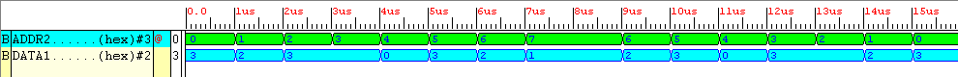

Figure Simulation results taken of the synthesised ENTITY ROM_MATRIX_STORE

By selecting addresses 7 down to 0, data a₁₁ a₁₂ a₂₁ a₂₂ b₁₁ b₁₂ b₂₁ b₂₂ will be outputted in that order. Notice the outputted data is an integer value, this is mainly for clarity reasons, integer data is easier to pick out and change accordingly.

The next step is to create a decoder which will manipulate the data.

IDEAS, instead of one input selecting one integer value, have multiple inputs signals selecting multiple output values. LOOK into this.

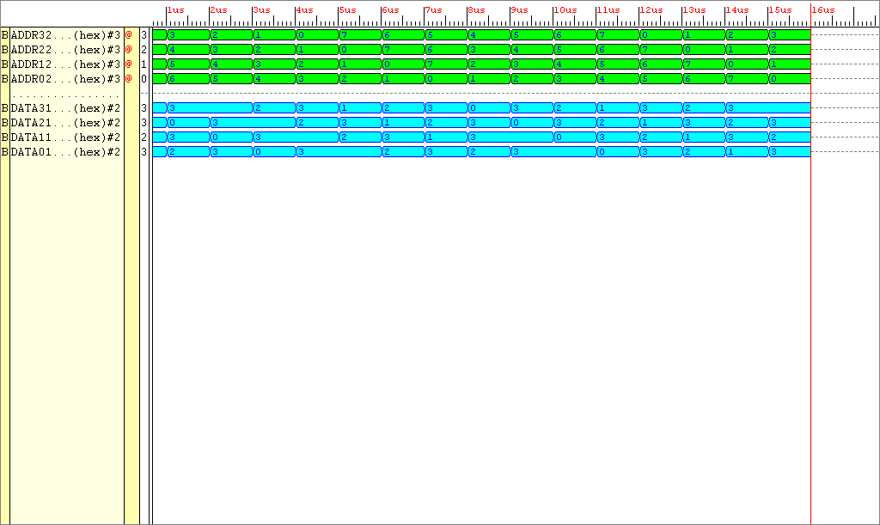
Figure Simulation results taken of the synthesised ENTITY ROM_MATRIX_STORE, this version has four select lines and four outputs

As can be seen each address line (green) selects data to be inserted onto it’s corresponding data line (blue).

By choosing memory address 7, element a₁₁’s data is inserted onto the corresponding data output
By choosing memory address 6, element a₁₂’s data is inserted onto the corresponding data output
By choosing memory address 5, element a₂₁’s data is inserted onto the corresponding data output
By choosing memory address 4, element a₂₂’s data is inserted onto the corresponding data output
By choosing memory address 3, element b₁₁’s data is inserted onto the corresponding data output
By choosing memory address 2, element b₁₂’s data is inserted onto the corresponding data output
By choosing memory address 1, element b₂₁’s data is inserted onto the corresponding data output
By choosing memory address 0, element b₂₂’s data is inserted onto the corresponding data output

Hows all this data processed to be ready for storage then, here’s a set of instructions which could be used to do just that ?

In mode 1

ASM controller selects data address 7 in the ENTITY ROM_MATRIX_STORE, data element a₁₁ is selected for output

ENTITY Decoder

This decoder needs to be a general system. If the value coming in is:-

29_01_2001

A few small ideas, I will be using the on board RAM in order to store matrix data to be used for matrix multiplication. In order to use this RAM, it’s data must be written in a Intel hex file format, then downloaded to the XS40 board using the Xsload, program. This will cause the schematic on page 2 to change slightly. To emulate the RAM, a behavioural ROM will be used for the moment (in any case the RAM is not required to be written to) .Lets think this through logically, what operations are required to get this to work.

A general aside, need to test a large bussed system (see if it uses those IO buffers that ruined Configurations 123), I’ll report back with the results.

Some worthwhile notes, using a decoder, you can select data using a std_logic_vector input and output the data as unsigned, makes sense doesn’t it! It took me a long time to figure this out.

Simple data

30_01_2001

Tests

I’ve tried to synthesise a 72 input output design. Error signal arising : The part has fewer input output ports (61) than that required by the design (72).
The design was an encoder that used 64 bit input, 8 bit output, hence overall ports (72). On the PC84 chip only 65 pins are available for the design. Remember.

